SOOCHEN LOW’S BIO FOR PRINT
“The Queen of Clearing Blocks to Joyful Living”
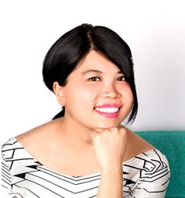
Honoured as “one of the most popular teachers in Hujiang” and "a woman who is filled with love, dreams, courage and the spirit of adventure plus other qualities such as "positive, kind, energetic, responsible, love life, patient, optimistic, generous and warm-hearted, in less than 2 years of teaching her programs to Chinese audiences on Hujiang, the biggest Internet learning platform in China with an active base of 80 million, Soochen Low, Happy.Positive.Successful Joy Expert & Coach received over 30,000 red flowers or likes for her programs plus now has a 200,000 loyal fan base. Also known by many as “The Queen of Clearing Blocks to Joyful Living”, she has helped thousands of women all over the world to unlock their BEST self by tapping into their joy ALL the time so that they can finally live the life of their dreams.

With 15 years of experience working with amazing clients with similar worries and concerns and guiding them to achieve remarkable success, Soochen’s students are always blown away by how she is able to pinpoint the exact source of where and how their BEST self has been locked away where books, self-development courses, psychologists and counsellors failed to uncover.

When one student was asked if she would recommend Soochen to people she knew, her answer was, "Yep, 'cause she is so generous, who doesn't love her?"

Other clients also say remarkable things about the impact of Soochen's work on their lives.

“Now I know the sunshine is always on my side and the darkness is just temporary. This helps me to move forward and stay on track for what I need to do in my life. At the end of the day, a sunny, positive outlook gives me a vitality that raises me up from the lowest of spirits to giddy heights. I am very grateful that I found Soochen. It was a coincidence that has changed my life so much.
With such a friend, mentor and champion in your corner, Soochen truly is the undisputed H.P.S Joy Expert who can help you to be happy.positive.successful all the time and live the life of your dreams- one that you truly love and enjoy what life throws at you.
To receive Soochen’s ‘Happy.Positive.Successful Formula Blueprint’ and 5 Step H.P.S Video Series, subscribe today at www.happypositivesuccessful.com.

